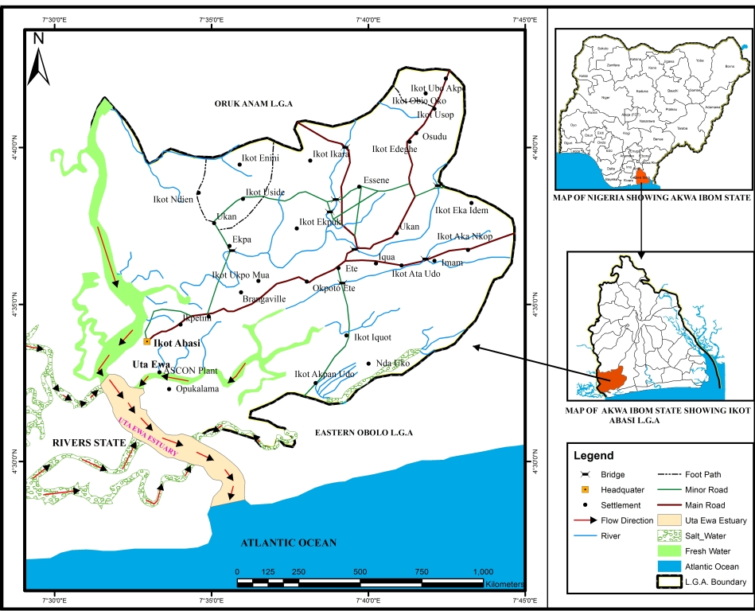
Fig. 1: Map of Ikot Abasi Local Government Area, Akwa Ibom State, Nigeria showing Uta Ewa Estuary and the sampling Stations.

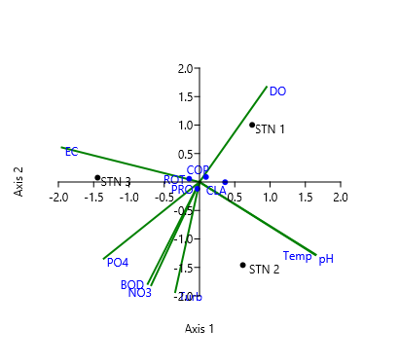
Fig. 2: Canonical correspondence analysis (CCA) ordination showing relationships between zooplankton groups, stations and environmental variables. (BOD – biochemical oxygen demand, DO - dissolved oxygen, Temp - water temperature, NO₃ – nitrates, PO₄ - phosphates, EC- electrical conductivity, Turb – turbidity, PRO – protozoa, ROT – rotifer, CLA – cladocera and COP – copepod)

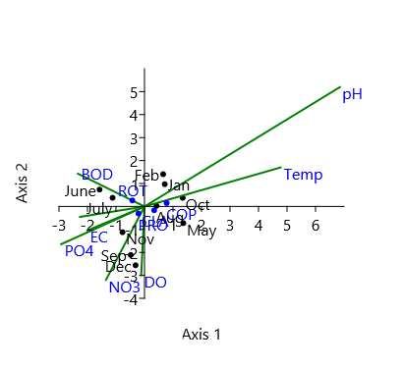
Fig. 3: Canonical correspondence analysis (CCA) ordination showing relationships between zooplankton groups, months and environmental variables. (BOD – biochemical oxygen demand, DO - dissolved oxygen, Temp - water temperature, NO₃ – nitrates, PO₄ - phosphates, EC- electrical conductivity, Turb – turbidity, PRO – protozoa, ROT – rotifer, CLA – cladocera, COP – copepod, Jan – January, Feb – February, Aug – August, Sep – September, Oct – October, Nov – November and Dec - December)

Table 1: Spatial variation of physico-chemical parameters of Uta Ewa Estuary Water
Parameter | Station 1  X±SEM | Station 2  X±SEM | Station 3  X±SEM | P-value
Temp (ºC) | 25.1±0.54  (22.8 – 27.5) | 25.3±0.55  (23.0 – 28.0) | 24.9±0.57  (22.9 – 27.9) | P>0.05
EC (mS/m) | 63.8±2.99  (45.0 – 75.0) | 62.3±3.29  (49.0 – 75.0) | 70.9±4.00  (53.0 – 88.0) | P>0.05
pH | 6.6±0.12  (6.3 – 7.5) | 6.7±0.15  (6.3 – 7.6) | 6.5±0.05  (6.2 – 6.7) | P>0.05
Turb (NTU) | 12.0±2.66ª  (3.2 – 30.4) | 28.2±2.37^{b}  (18.9 – 45.1) | 21.8±2.55^{b}  (12.0 – 35.5) | P<0.05
DO (mg/l) | 4.7±0.46ª  (2.9 – 7.8) | 3.8±0.42^{b}  (2.2 – 6.0) | 3.9±0.49^{b}  (1.9 – 6.8) | P<0.05
BOD (mg/l) | 2.3±0.33  (0.2 – 3.6) | 3.2±0.39  (1.7 – 5.3) | 3.0±0.43  (1.0 – 4.6) | P>0.05
Phosphate (mg/l) | 3.2±0.40ª  (1.5 – 5.4) | 4.8±0.55^{b}  (2.3 – 7.7) | 5.2±0.54^{b}  (2.8 – 7.8) | P<0.05
Nitrate (mg/l) | 3.0±0.55ª  (1.0 – 5.8) | 6.3±0.34^{b}  (4.6 – 8.0) | 5.5±0.55^{b}  (2.9 – 8.0) | P<0.05
a, b = means with different superscripts across the row are significantly different at P<0.05; SEM = Standard Error of mean.

Table 2: Temporal variation of physico-chemical parameters of Uta Ewa Estuary Water
Months/  Parameters | Temp  (ºC)  X±SEM | EC (mS/m)  X±SEM | pH  X±SEM | Turb  (NTU)  X±SEM | DO (mg/l)  X±SEM | BOD (mg/l)  X±SEM | Phosphate (mg/l)  X±SEM | Nitrate (mg/l)  X±SEM
May 2019 | 23.6±0.32^{ab}  (23.0 – 24.0) | 77.0±5.86  (68.0 – 88.0) | 6.5±0.09  (6.3 – 6.6) | 21.4±4.92^{ab}  (15.1 – 31.1) | 2.8±0.29ª  (2.3 – 3.3) | 3.5±0.81^{bc}  (2.0 – 4.8) | 4.3±0.38^{abc}  (3.5 – 4.7) | 6.0±0.75^{ab}  (4.7 – 7.3)
Jun. 2019 | 23.0±0.06ª  (22.9 – 23.1) | 71.3±1.86  (69.0 – 75.0) | 6.4±0.12  (6.2 – 6.6) | 24.6±3.18^{ab}  (21.0 – 30.9) | 3.2±0.50^{ac}  (2.2 – 3.9) | 4.0±0.64^{b}  (3.2 – 5.3) | 5.9±1.23^{bc}  (3.6 – 7.8) | 6.0±1.70^{ab}  (2.6 – 8.0)
Jul. 2019 | 22.9±0.09ª  (22.8 – 23.1) | 71.0±3.51  (64.0 – 75.0) | 6.4±0.03  (6.3 – 6.4) | 25.6±8.69^{ab}  (8.3 – 35.5) | 3.6±0.38^{ac}  (2.9 – 4.2) | 3.9±0.38^{bc}  (3.3 – 4.6) | 4.0±1.39ª  (2.5 – 6.8) | 5.0±1.54^{ab}  (2.5 – 7.8)
Aug. 2019 | 24.6±0.31^{b}  (24.0 – 25.0) | 72.3±4.84  (67.0 – 82.0) | 6.6±0.09  (6.4 – 6.7) | 33.4±6.05^{b}  (24.8 – 45.1) | 2.4±0.29ª  (1.9 – 2.9) | 3.8±0.39^{bc}  (3.4 – 4.6) | 6.9±0.74^{b}  (5.4 – 7.7) | 5.8±0.06^{ab}  (5.7 – 5.9)
Sep. 2019 | 24.0±0.09^{ab}  (23.8 – 24.1) | 72.0±8.32  (60.0 – 88.0) | 6.4±0.07  (6.3 – 6.5) | 24.7±6.58^{ab}  (12.0 – 34.0) | 3.4±0.57^{ac}  (2.3 – 4.1) | 3.6±0.03^{bc}  (3.5 – 3.6) | 5.7±0.61^{bc}  (4.8 – 6.9) | 6.3±0.98^{b}  (4.6 – 8.0)
Oct. 2019 | 26.3±0.27^{c}  (25.9 – 26.8) | 56.0±8.62  (45.0 – 73.0) | 7.0±0.32  (6.5 – 7.6) | 19.0±4.75^{ab}  (9.6 – 25.0) | 4.9±0.17^{bc}  (4.7 – 5.2) | 2.6±0.38^{bc}  (2.2 – 3.4) | 4.0±0.58^{ac}  (3.4 – 5.2) | 5.6±0.64^{ab}  (4.4 – 6.6)
Nov. 2019 | 25.9±0.09^{c}  (25.7 – 26.0) | 59.7±6.06  (49.0 – 70.) | 6.5±0.03  (6.4 – 6.5) | 15.6±5.52ª  (8.3 – 26.4) | 5.4±0.50^{bc}  (4.4 – 6.0) | 1.7±0.38^{bc}  (1.0 – 2.3) | 4.3±0.39^{abc}  (3.5 – 4.8) | 4.5±1.73^{ab}  (1.0 – 6.3)
Dec. 2019 | 26.0±0.58^{c}  (25.0 – 27.0) | 59.0±3.79  (53.0 – 66.0) | 6.4±0.06  (6.3 – 6.5) | 16.0±4.40ª  (7.3 – 21.6) | 6.6±0.76^{b}  (5.2 – 7.8) | 1.6±0.28^{ac}  (1.0 – 1.9) | 3.3±0.56^{ac}  (2.2 – 4.0) | 4.2±1.02^{ab}  (2.3 – 5.8)
Jan. 2020 | 27.8±0.15^{d}  (27.5 – 28.0) | 57.9±3.94  (53.0 – 65.7) | 6.9±0.33  (6.4 – 7.5) | 12.0±4.62ª  (3.2 – 18.9) | 4.8±0.45^{ab}  (4.2 – 5.7) | 1.3±0.61ª  (0.2 – 2.3) | 3.4±1.00^{ac}  (1.5 – 4.9) | 3.3±1.23^{ab}  (1.4 – 5.6)
Feb. 2020 | 27.0±0.12^{cd}  (26.8 – 27.2) | 60.3±7.42  51.0 – 75.0) | 6.9±0.33  (6.5 – 7.5) | 14.7±5.83ª  (4.4 – 24.6) | 4.4±0.76^{ab}  (3.2 – 5.8) | 2.5±0.53^{bc}  (1.5 – 3.3) | 2.3±0.29ª  (1.8 – 2.8) | 2.8±1.04ª  1.0 – 4.6
P-value | P<0.05 | P>0.05 | P>0.05 | P<0.05 | P<0.05 | P<0.05 | P<0.05 | P<0.05
a, b = means with different superscripts across the row are significantly different at P<0.05; SEM = Standard Error of mean.

Table 3: The Spatial Zooplankton Composition, Abundance and Distribution
Taxonomic  Group | Species Composition | Stn. 1 | Stn. 2 | Stn. 3 | Total
Protozoa | Carchesium polypium | 2 | 4 | 0 | 6
 | Didinium bolbanni | 9 | 28 | 20 | 57
 | Tintinnopsis lacustries | 18 | 10 | 0 | 28
 | Paramecium caudatum | 3 | 8 | 12 | 23
 | Oikomonas rostratum | 0 | 0 | 35 | 35
 | Spirostomum ambiguum | 35 | 28 | 19 | 82
 | S. teres | 28 | 10 | 17 | 55
 | S. macronucleus | 19 | 24 | 11 | 54
Cladocera | Alona exima | 8 | 0 | 16 | 24
 | Alona rectangular | 4 | 0 | 21 | 25
 | Bosmina longirotris | 9 | 13 | 3 | 25
 | Chydorus piger | 20 | 35 | 0 | 55
 | Pleuroxus levis | 0 | 0 | 18 | 18
Rotifera | Lecane bulla | 27 | 0 | 32 | 59
 | L. quadridentata | 26 | 0 | 19 | 45
 | L. langsenensis | 14 | 3 | 14 | 31
 | Asplanchna priodonata | 17 | 31 | 0 | 48
 | Keratella cochlearis | 0 | 0 | 16 | 16
 | K. quarata | 0 | 0 | 13 | 13
 | Asplanchna brightwelli | 10 | 26 | 19 | 55
 | Gastropus hyptopus | 8 | 0 | 0 | 8
 | Synchaeta pectinata | 2 | 10 | 8 | 20
 | Conochilus unicornis | 28 | 14 | 19 | 61
Copepoda | Calanus glacialis | 14 | 0 | 6 | 20
 | Cyclops strenuous | 16 | 24 | 18 | 58
 | Diaphanasoma excisum | 7 | 0 | 0 | 7
 | Tropocyclops prasinus | 24 | 19 | 29 | 72
 | Eucalanus elongates | 14 | 3 | 10 | 27
 | Nauplius | 18 | 0 | 0 | 18
 | Zoeo larva | 8 | 13 | 0 | 21

Table 4: The Temporal Zooplankton Composition, Abundance and Distribution
 |  | 2019 |  |  |  |  |  |  |  | 2020
Taxonomic Group | Species (Taxa) | May | June | July | Aug. | Sept. | Oct. | Nov. | Dec. | Jan. | Feb.
Protozoa | Carchesium polypium | 0 | 1 | 1 | 1 | 2 | 0 | 0 | 1 | 0 | 0
 | Didinium bolbanii | 10 | 10 | 13 | 0 | 4 | 0 | 8 | 8 | 0 | 4
 | Tintinnopsis lacustries | 2 | 0 | 4 | 6 | 1 | 4 | 2 | 7 | 1 | 1
 | Paramecium caudatum | 4 | 0 | 0 | 4 | 4 | 1 | 0 | 0 | 10 | 0
 | Oikomonas rostratum | 8 | 3 | 4 | 0 | 3 | 4 | 0 | 2 | 3 | 8
 | Spirostomum ambiguum | 0 | 5 | 15 | 25 | 8 | 0 | 18 | 8 | 3 | 0
 | S. teres | 8 | 16 | 0 | 14 | 0 | 2 | 10 | 3 | 2 | 0
 | S. macronucleus | 0 | 15 | 14 | 3 | 8 | 9 | 0 | 3 | 2 | 0
Cladocera | Alona exima | 3 | 0 | 10 | 11 | 0 | 0 | 0 | 0 | 0 | 0
 | Alona rectangular | 4 | 0 | 8 | 3 | 0 | 0 | 2 | 1 | 1 | 6
 | Bosmina longirotris | 10 | 0 | 5 | 0 | 5 | 1 | 0 | 2 | 2 | 0
 | Chydorus piger | 10 | 0 | 2 | 20 | 13 | 6 | 0 | 0 | 4 | 0
 | Pleuroxus levis | 0 | 0 | 0 | 0 | 0 | 8 | 0 | 2 | 4 | 4
Rotifera | Lecane bulla | 0 | 22 | 18 | 0 | 0 | 0 | 7 | 0 | 3 | 9
 | L. quadridentata | 3 | 0 | 18 | 12 | 0 | 0 | 4 | 0 | 8 | 0
 | L. langsenensis | 0 | 10 | 0 | 6 | 0 | 8 | 0 | 0 | 3 | 4
 | Asplanchria priodonata | 0 | 2 | 5 | 3 | 15 | 5 | 8 | 0 | 5 | 5
 | Keratella cochlearis | 1 | 22 | 18 | 10 | 0 | 0 | 0 | 2 | 2 | 0
 | K. quaratqa | 2 | 10 | 0 | 3 | 0 | 0 | 0 | 1 | 0 | 0
 | Asplanchina brihtwelli | 0 | 0 | 9 | 1 | 0 | 0 | 2 | 0 | 1 | 0
 | Gastropus hyptopus | 2 | 3 | 0 | 1 | 0 | 0 | 0 | 0 | 2 | 0
 | Sychaeta pectinata | 1 | 1 | 6 | 0 | 0 | 3 | 2 | 0 | 0 | 7
 | Conochilus unicornis | 0 | 10 | 15 | 18 | 0 | 0 | 0 | 4 | 8 | 6
Copepoda | Calanus glacialis | 0 | 0 | 0 | 5 | 0 | 4 | 1 | 0 | 5 | 5
 | Cyclops strenuous | 10 | 0 | 0 | 8 | 0 | 13 | 0 | 0 | 10 | 17
 | Diaphanasoma excisum | 0 | 0 | 0 | 0 | 0 | 0 | 3 | 3 | 0 | 1
 | Tropocyclops prasinus | 15 | 0 | 0 | 18 | 0 | 20 | 0 | 0 | 19 | 0
 | Eucalanus elongates | 10 | 0 | 0 | 7 | 0 | 0 | 0 | 0 | 4 | 6
 | Nauplius sp | 0 | 0 | 0 | 14 | 0 | 0 | 2 | 0 | 0 | 2
 | Zoeo larva | 10 | 0 | 0 | 0 | 0 | 6 | 1 | 3 | 1 | 1

Table 5: The Spatial Diversity indices of Zooplankton Community
Ecological indices | STN. 1 | STN. 2 | STN. 3
No. of species | 26 | 18 | 22
No. of individual | 388 | 303 | 375
Margalef’s index (D) | 4.194 | 2.975 | 3.543
Shannon-wiener (H) | 3.069 | 2.703 | 2.989
Evenness (E) | 0.8279 | 0.8293 | 0.9029

Table 6: The Temporal Diversity indices of Zooplankton Community
Ecological | 2019 |  |  |  |  |  |  |  | 2020
Indices | May | Jun | Jul | Aug. | Sep | Oct. | Nov. | Dec. | Jan. | Feb.
No. of Species | 18 | 14 | 17 | 22 | 10 | 15 | 14 | 15 | 23 | 16
No. of Individuals | 113 | 130 | 165 | 193 | 63 | 94 | 70 | 50 | 103 | 86
Margalef Index (D) | 3.596 | 2.671 | 3.134 | 3.990 | 2.172 | 3.081 | 3.060 | 3.579 | 4.747 | 3.367
Shannon-wiener (H) | 2.658 | 2.336 | 2.643 | 2.796 | 2.063 | 2.446 | 2.281 | 2.489 | 2.808 | 2.541
Evenness (E) | 0.792 | 0.739 | 0.827 | 0.744 | 0.787 | 0.769 | 0.699 | 0.803 | 0.721 | 0.793

