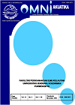
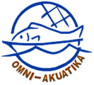
Omni-Akuatika, 11 (2): 1–5, 2015
ISSN: 1858-3873 print / 2476-9347 online
Research Article

Analysis of Heavy Metal Cadmium (Cd) Content on Mud Crab (Scylla sp.) at Wonorejo River Surabaya

Nanang Ardianto¹, Prayogo² dan Adriana Monica Sahidu²

¹ Aquaculture Study Program, Faculty of Marine and Fisheries, Universitas Airlangga,
Jl. Mulyorejo Kampus C Unair, Surabaya 60115, Indonesia
² Department of Marine, Faculty of Marine and Fisheries, Universitas Airlangga, Jl. Mulyorejo Kampus C Unair, Surabaya 60115, Indonesia

*Corresponding author: nanangardianto17121996@gmail.com

ABSTRACT

The coastal waters of Wonorejo is part of the East Coast Surabaya which receive the brunt of watersheds (DAS) from other rivers. The main source of heavy metal wastes in the River on the downstream Wonorejo pass several industries suspected of disposing of hazardous waste. One of the main heavy metal which is a toxic element and effect on aquatic ecological systems are cadmium (Cd).Mud crab is one potential biota found in the mangrove area of Wonorejo River Surabaya can accumulate heavy metals. This research was carried out in April 2018 with sampling at three stations with time each week for three times.Analysis of heavy metals cadmium (Cd) in mud crabs (Scylla sp.), water and sediments carried out in the laboratory of nutrition of the Faculty of public health University Airlangga. Research method using observation which is channeled in the waters and farmed in Wonorejo Surabaya. Mud crab meat samples, water and sediments tested using Atomic Absoption Spectrophotometry (AAS). The results of the test concentration of heavy metals cadmium (Cd) in mud crab meat on the river Wonorejo i.e. 0.032 mg.kg⁻¹ where the value of these levels are still below the threshold of quality raw heavy metal Cd on crustaceans i.e. 1 mg.kg-1 (SNI 7387:2009). The Cd content in water of Wonorejo river in between 0.014-0.02 ppm and on sediments between 0.234-0.416 mg/kg. Correlation of cadmium content in water with crab meat in the correlation coefficient shows of Wonorejo -0.22 (a weak correlation, a negative direction). Then, the correlation of the content of cadmium in sediments with crab meat in the correlation coefficient shows of Wonorejo 0.285 (of correlation is weak, the positive direction).

Keywords: Heavy metals, Cadmium, Scylla sp., AAS

1. Introduction
The coastal waters of Wonorejo is part of the East Coast Surabaya where received impact Watersheds (DAS) from the other rivers in the vicinity. Wonorejo River potentially accumulate a load of anthropogenic due to the abuse of the River as a place of waste disposal so that the load will be distributed to polluters to the estuaria of the River to the Sea (Badan Lingkungan Hidup Kota Surabaya, 2011). The main source of heavy metal in sewage downstream Wonorejo passing through several industries, among which five steel industry polymer industry, 1, and 60 more types of industries suspected of disposing of hazardous waste (Arisandi, 1999).
One of the sources of danger that is air-polluters heavy metals cadmium (Cd) which is a toxic element and effect on aquatic ecological systems. The final results of the monitoring of the content of cadmium in the river waters Wonorejo Surabaya ever undertaken by the environmental agency of the city of Surabaya from the year 2008-2009 is 0.05 mg/L that have passed quality raw levels of heavy metal impurities. Though, later experienced a decline in 2011 amounting to 0.03 mg/L.
Mud crab is one potential biota there are in the region of the Wonorejo River Surabaya. Annual report the capture fishery production statistics of commodity crab in East Java province mainly in the city of Surabaya to reach 210 tons (Dinas Kelautan Perikanan, 2014). Then, decrease the production of crab results in 2016 be 184.69 tons (Dinas Ketahanan Pangan dan Pertanian Kota Surabaya, 2017).

2. Materials and Methods
  - Determination of The Sampling Station

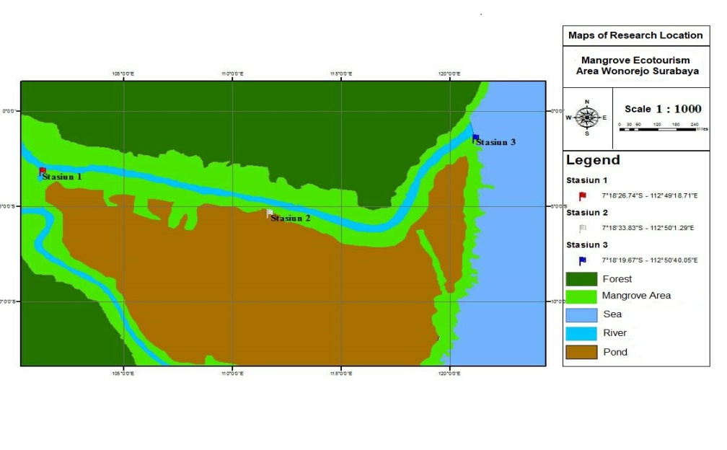

Figure 1. Location of Research

Determination of water, taking station in the sediments and the crab meat was done in advance of a survey to find out the circumstances of geography and activities around environmental research (Hadi, 2007). Then, the determination of the geographical coordinates of each sampling station using the Global Positioning System (GPS). Map at each sampling station research can be seen in Appendix 2. The point coordinates of the three sampling stations is research Station 1 (7 ° 18 ' 26.74 "LS-112 ° 49 ' 18.71" BT), Station 2 (7 ° 18 ' 33.83 "LS-112 ° 50′ 1.29" E), and Station 3 (19.67 ° 18 ' 7 "LS-112 ° 50′ 40.05" BT).
Station 1 : taken at the beginning of the region’s mangrove wonorejo river, located 2.2 km from the estuaria of the river.
Station 2 : taken in the area of ponds near the Wonorejo river, 1.3 km from the estuaria of the river.
Station 3 : taken at the end of the mangrove area at the estuaria of the Wonorejo River and the cruise line fishing boat..

2.2. Research Sampling

Mud crab, water and sediments sampling using a simple random sampling method (simple random sample)

A. Mud Crab Meat Sample
The process of retrieving a crab high tide the water is done by installing a capture tool at a location has been determined. Then, capture tool that has been memperangkap crab taken after passing the tide water (WWF Indonesia, 2015). The existence of the ups and downs shows that there is penggenangan of water in ecosystems which could result directly to the existence of mud crab. Crabs caught each station totaling 10 tail with wide range of carapace between 9 – 12 cm. Then, crab catches taken flesh in a way solve the carapace using a Nutcracker crab. Then, the crab meat from each station dihomogenkan for weighted fits the needs test sample weight of 50 grams, and put into a plastic bag which serves avoiding an increase in contamination. After that, the samples are ready to be tested to the lab to find out the concentration of metal weighing.

B. Water Sample
Water sampling was taken by using a water sampler under the surface of the water as much as 50 ml at each station. Bottles containing samples of the water then put cool box containing ice cubes so as not happening biologically and chemically changes. Subsequently closed in meetings and carried out connections to laboratories to do observations of the content of heavy metals.

C. Sediment Sample
Sampling sediments at the station can use Ekman Grab with depth 10-25 cm from the surface. The amount of sediment that is needed for each station of 50 grams. Sediments that have been taken are put in plastic bags. A plastic bag containing samples of sediment put cool box containing ice cubes so as not happening biologically and chemically changes. Subsequently closed in meetings and carried out connections to laboratories to do observations of the content of heavy metals.

  - Pengujian Logam Berat Kadmium

The testing of heavy metal cadmium on mud crab meat, water and sediments using Atomic Absoption Spectrophotometry (AAS) who on his principle of utilizing the abundance of light absorbed is directly proportional to the levels of the substances (Eason, 2007).
Testing of cadmium with AAS in General through several procedures, namely lit set of AAS and set up the hollow cathlode lamp. Then, AAS determined has been connected to the computer, and then connect it with the standard solution and the sample that was made earlier. Next, do an analysis of the standard solutions and the sample absorbance value, assess each solution, make the curve of absorbance and noted the concentrations of cadmium in samples
2.4 Analisis Data
The data test result in the form of concentration of heavy metals cadmium (Cd) that have been obtained from mud crab meat, water, and sediment were processed by using the Test program through Correlation Statistical Product and Service Solution (SPSS) version 22.

3. Results and Discussion

3.1. The Cadmium Content on Water

The concentration of heavy metals in the waters of the River at three observation stations Wonorejo retrieved results ranged from 0.014 – 0.02 ppm which exceed the threshold that has been set out in the decision of the Minister of the environment no. 51 Year 2004 about raw water quality for the marine life that is 0.001 ppm. Although, the concentration value has decreased from previous observations by the environmental agency of the city of Surabaya in the year 2008 amounting to 0.03 ppm.
Decrease in accumulation of the heavy metal cadmium in waters can occur due to the increasing process of rizofiltrasi (the root of the plant's ability to absorb, precipitate, and accumulate the metals from the waste stream) by mangrove plants (Tsao, 2003). Many mangrove plants are found along the river sampling station Wonorejo Surabaya which is also the habitat of mud crabs (Scylla sp.).
Other factors such as wind speed and flow also considerable influence on heavy metal content of fluctuations on water sampling station research. Palar (2004), stating that the current causes a mass of moving water because of the wind, or because of the difference in the density of sea water and can also be caused by the movement of the waves. The direction and speed of the flow influences the process of displacement and the churning waters, such as micronutrients and suspended material. The process of moving and chemical impurities thins including heavy metals following the movement of the water.

Table 1. Average Concentrations of Heavy Metals Cadmium (Cd) in Mud Crab Meat (Scylla sp.), Water and Sediment on The Wonorejo River Surabaya

Sampling Point | Mud Crab Meat  (mg.kg⁻¹) | Water  (ppm) | Sediment  (mg.kg⁻¹)
Station I | 0.024 | 0.02 | 0.416
Station II | 0.04 | 0.018 | 0.234
Station III | 0.032 | 0.014 | 0.313
Average (±SD) | 0.032 ± 0.008 | 0.017 ± 0.003 | 0.321 ± 0.091

3.2. The Cadmium Content on Sediment

The concentration of heavy metals in River sediments at three observation stations Wonorejo retrieved results between 0.234 – 0.416 mg/kg that show does not exceed the thresholds set in the ANZECC 2000 Year ARMCANZ and about the raw quality of sediment in water for the marine life that is 1.5 – 10 mg/kg. This is due to sediments suspended by the easy movement of water masses that dissolve back heavy metals contained in the water.
Sediment sampling results in three stations obtained concentrations of cadmium that is greater than in the water. It is suitable according to Darmono (1995) that the concentration of heavy metals in the sediments will always be higher than the water. Heavy metals in waters can move towards sediment periodically because the mass of jeninsya greater than the density of water (Cotton and Wilkinson, 1986). Cadmium has a mass kind of 8.65 gr/cm3 (Widowati, 2008). Heavy metal that accumulates in the water column within a long period of deposition to the base so that it accumulates in aquatic sediments (Hutagalung, 1994).

3.3. Cadmium Content on Mud Crab Meat

Heavy metal concentrations on mud crab meat at three observation stations retrieved the results ranged from 0.024 – 0.041 mg/kg. This show does not exceed a threshold based on the national standards of Indonesia No. 7387 Year 2009 maximum limit of exposure to cadmium content of heavy metals in fishery products in particular meat crustaceans i.e. 1.0 mg/kg. These results indicate that the mud crab catches in all areas of observation are still safe for consumption.
Heavy metals can be moved from the environment into the body of the organism. Then, from one organism to other organisms through the food chain (Yalchin et al., 2008). If it is absorbed into the body of an organism then heavy metal hard crush but will accumulate on it to wasted through excretion in long periods (Connel and Miller, 1995). In the body of the aquatic biota amounts of metal accumulated will continue to experience increased (Nowrouzi, et al., 2012). The results showed concentrations of cadmium on mud crab meat still quite low because crab catches suspected when the average research was young and medium-sized so that the process of accumulation of heavy metals not yet run to the maximum.

3.4. Water Quality Parameters

The parameters observed waters as supporting this research include pH, temperature, and salinity. The results of the temperature measurement during research progresses, the temperature of the surface waters of the river Wonorejo Surabaya ranges between 28-32 ˚ C. According to the Ministry of the environment no. 51 Year 2004, temperatures are common in the waters of the sea of Indonesia range between 28-32 ˚ C. The range of temperature of the surface waters during research carried out still in the normal range. The process of absorption of heavy metals can be affected by the temperature of the waters, if the temperature is high then it will increase the formation of heavy metal ions, thereby increasing the deposition process (Hutagalung, 1984).
The value of the salinity in the waters of the river Wonorejo Surabaya during the study ranged 0-6 ppt. Salinity in the water can affect the concentration of the heavy metals pollute the environment. If the salinity at low waters caused the level of heavy metal accumulation in organisms is so large (Muhktasor, 2007).
The measurement of the pH value in the waters of the river Wonorejo Surabaya demonstrates the trend value of pH is basa and stable range of value 6-8 with an average of 7.7. Based on the range of value of the condition of the waters of the river still appropriate Wonorejo NAB allowed the Ministry of environment no. 51 Year 2004 i.e. pH 7-8.5. According to Connel and Miller (1995) explains that the pH of seawater is high will encourage the deposition of heavy metals so that simply applied in sediments are generally higher.

3.5. Relationship between The Cadmium Content on Mud Crab Meat, Water, and Sediment
A simple regression test results to find out the correlation between the content of cadmium in water with mud crab meat shows the result of a weak negative correlation with directions (R =-0.22). This means that the river water Wonorejo did not significantly affect her little big concentrations of cadmium on mud crab meat.
Whereas, the correlation between the content of cadmium in sediments of mud crab meat with also shows the result of a weak positive correlation with directions (R = 0.285). This means that the River sediments Wonorejo did not significantly affect her little big concentrations of cadmium on mud crab meat. Although a positive correlation means direction, if the content of cadmium in cadmium content of up sediment on mud crab meat will also increase.
The presence of a weak correlation antarvariabel of water and sediments with crab meat means a quantity value of the concentration of cadmium in the mud crab meat (Scylla sp.) on the river Wonorejo Surabaya more influenced by other factors. Those factors such as water quality, season physical properties physical properties waters, bioremediation of mangrove plants and mud crab biology from nature (Scylla sp.).

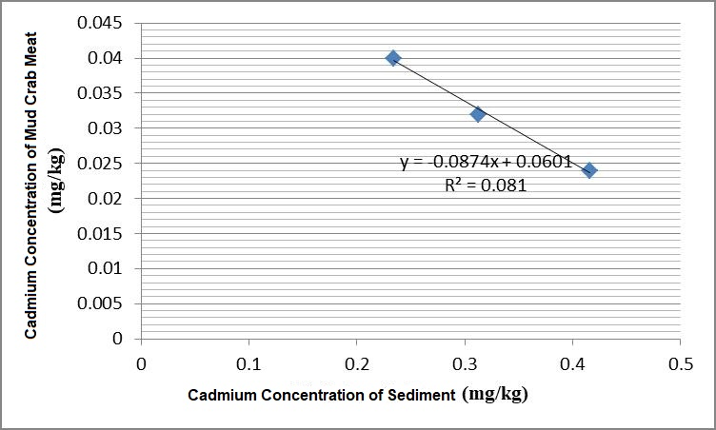

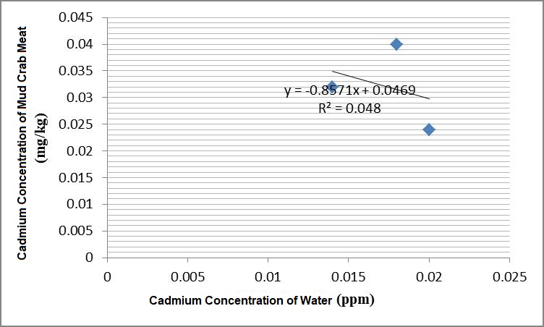

Figure 2. The Relationship between Cadmium Content on Crab Meat with Water and The Relationship between Cadmium Content on Crab Meat with Sediment.

These relationships can be seen in Figure 2.

3.6 Mud Crab Catches During The Research Takes Place

The results of measurements of the carapace width and weight of Scylla sp. catches over the last three weeks of research in Wonorejo River Surabaya in rainy season showed a variation of sizes. The measurement of the width of the carapace Scylla sp. on each station obtained an average of sequentially, i.e. 8.94 cm, 9.83 cm, and 9.99. Measurement of weight of Scylla sp. at each station were obtained on average, i.e. 147.26 gr, 164.26 gr, and 172.3 gr.
Scylla sp. with larger sizes found on station 3. This is due to that location is the area of the estuary near the coast of the overgrown mangrove vegetation. This condition is the most suitable natural habitat for mud crabs (Cholik & Hanafi 1992). Mud crabs live in the intertidal
and subtidal habitat, where they are predominantly prey on molluscs and other invertebrates are less moving, such as the home, snails, crabs, and worms (Arifin, 2006).

4. Conclusion

Based on the results of research that has been done, then the conclusions of this research are the content of heavy metals cadmium (Cd) in mud crab meat (Scylla sp.) in Wonorejo River Surabaya ranged from 0.024 – 0.041 mg/kg. Thus, mud crab meat (Scylla sp.) on the river Wonorejo Surabaya are still safe for consumption by humans because it is still under heavy metal impurities thresholds of cadmium specified, i.e., 1.0 mg/kg (SNI 7387:2009).

References

ANZECC and ARMCANZ. 2000. Australian and New Zealand Guidelines for Fresh and Marine Water Quality. Australian and New Zealand Environment and Conservation Council dan Agriculture and Resource Management Council of Autralia and New Zealand. Australia: Canberra Act. 126.

Arifin, Z. 2006. Carrying Capacity Assessment on Mangrove Forest with Special
Emphasize on Mud Crab Sylvofishery System: A Case Studi in Tanjung
Jabung Timur District Jambi Province. Thesis. Post Graduate School.
Bogor Agricultural University. 20.

Arisandi, Prigi. 1999. Struktur dan Komposisi Mangrove Pantai Timur Surabaya. Surabaya. Skripsi. Surabaya. Universitas Airlangga. 10-13.

Badan Lingkungan Hidup Kota Surabaya. 2011. Laporan Kegiatan Pengendalian Pencemaran Kawasan Pantai Dan Pesisir. Surabaya. 1-5.

Badan Standarisasi Nasional. 2009. SNI 7387: 2009 Tentang Batas Maksimum Cemaran Logam Berat dalam Pangan. 7-9.

Cholik, F., A, Hanafi. 1992. A Review of the status of mud crab fishery and culture in Indonesia. Central Research Institute for Fisheries. Jakarta. 6.

Connel, D.W. dan Miller, G.J. 1995. Kimia dan Ekotoksikologi Pencemaran. Jakarta: UI Press. 150.

Cotton, A and Geoffrey Wilkinson, 1989. Kimia Anorganik Dasar. Penerbit UI-Press. Jakarta. 132.

Darmono. 1995. Logam dalam Sistem Biologi Makhluk Hidup. Jakarta (ID): UI Press. 140.

Dinas Perikanan dan Kelautan Provinsi Jawa Timur. 2014. Laporan Tahunan Statistik Perikanan Tangkap di Jawa Timur. Surabaya. 34.

Dinas Ketahanan Pangan dan Pertanian Kota Surabaya. 2017. Produksi Ikan Laut Menurut Jenisnya (Ton) 2011-2016. Surabaya.

Hutagalung, H.P. 1984. Logam Berat Dalam Lingkungan Laut. Jurnal Oceana. LIPI. Jakarta. 1-10.

Menteri Negara Lingkungan Hidup. 2004. Keputusan Menteri Nomor 52 Tahun 2004 Tentang Baku Mutu Air Laut. Jakarta. 1497

Mukhtasor. 2007. Pencemaran Pesisir dan Laut. Pradnya Paramita. Jakarta. 50.

Mamboya, F.A. 2007. Heavy Metal Contamination and Toxicity. Stockholm University. 160.

Nowrouzi, M., Pourkhabbaz, A., Rezaei, M. 2012. Bioaccumulation and Distribution of Metals in Sediments and Avicenna Marina Tissues in The Hara Biosphere Reserve, Iran. Bull Environ Contam Toxicol.799-804.
Palar, H. 2004. Pencemaran dan Toksikologi Logam Berat Edisi 2. PT Rineka Cipta. Jakarta. 110.

Satori, Djam’an dan Aan, Komariah. 2009. Metodologi Penelitian Kualitatif. Bandung: Alfabeta. 22

Tsao, DT. 2003. Phytoremediation: Advance in Biochemical Engineering Biotechnology. Springer. Berlin Heidelberg. 67.

Widowati, W. 2008. Efek Toksik Logam Pencegahan dan Penanggulangan Pencemaran. Yogyakarta: Penerbit Andi. 36.

Yalcin, G., Narin, I., Soylak, M. 2008. Multivariate Analysis of Heavy Metal Contents of Sediments From Gumusler Creek, Nigde, Turkey. Environmental Geology. 1155-1163.

