Spawning Potential Ratio of Feather Back (Chitala Lopis) at Kampar River, Riau

Andri Warsa ¹, Endi Setiadi Kartamihardja ² dan Arif Wibowo³

¹ Balai Riset Pemulihan Sumberdaya ikan
Jln Cilalawi No 1Jatiluhur, Purwakarta, Jawa Barat
² Pusat Riset Perikanan
Jalan Pasir Putih II, Ancl Timur 14430 Jakarta Utara
³ Balai Riset Perikanan Perairan umum dan Penyuluhan Perikanan
Jalan Gubernur H.A Bastari No. 08 Jakabaring, Palembang, Sumatera Selatan

*Coresponding author: andriwarsa@yahoo.co.id

ABSTRACT

The feather back, Chitala lopis is an important economic fish, inhabit Kampar River and its population tend to decrease so that management and conservation efforts should be conducted. Limited data of the feather back is one of the problems in formulating the management of the population. Spawning potential ratio (SPR) approach is an option being used in the management of the fish stock in the poor data. The study aimed to analysis spawning potential ratio of the feather back in Kampar River, Riau. The research has been conducted in May, August and October 2016. The total length at first capture (L_{c}) of feather back was less than the total length at first maturity (L_{m}) with the SPR value of 5 %. This condition could impact to decreasing the feather back stock. The SPR value should increased more than 20 % so the feather back population would been stable. Regulation of the fisheries was mainly limited mesh size of the gillnet operated should be applied.

Keywords: Habitat, spawning potential ratio, feather back, Kampar River

- Introduction

Kampar River have a huge diversity of fish species, of which 58 species are found in Kampar Kanan (Fithra & Siregar, 2010) and 86 species are found in Kampar Kiri River (Simanjuntak et al., 2006). The distribution of this species include Borneo, Java and Sumatera (Haryono, 2008). Feather back in Kampar River is important economically value but it’s species in endangered status (Aryani, 2015). Stock of feather back in Kampar River was divided into two stocks zona, namely in upstream and downstream. The Feather back in Kampar River also shows different genetic characteristics with these species from Musi and Barito Rivers (Wibowo & Marson, 2012). Feather Back is carnivore fish and can utilize fish juvenile, shrimp, insect, worm, benthos and plant as natural food (Burnawi, 2009; Wibowo, 2014). For the optimize and sustainable of harvest it need conservation and management for this species. This objectives of fish resource management is to optimize the production of harvest while maintaining the sustainability of resources, without over exploitation, and maintaining of stock health and also improving stocks condition (Cope & Punt, 2009).

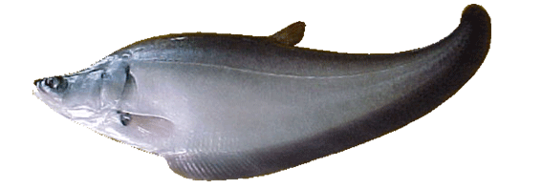
Figure 1. Feather Back (Chitala lopis Blkr)

In generally, fisheries resource management is based on stock biomass and biological parameters of target fish (Wiedenmann et al., 2013; Carruthers et al., 2014). its model requires catches data on several years, the abundance of fish at a certainly age and the life cycle of target species (Deroba & Bence, 2008), whereas the data about feather back fisheries in Kampar River is limited (poor data). Secondary data as production, number of fishing gear and trip, and number of fishermen in time series are not available. The approach that can be usage to determine the status of fisheries and formulate management with limited data (MacCall, 2009) can be done based on biological parameters ie infinity length, growth constant and length at first mature and length frequency (Wayte & Klaer, 2010). The approach for feather back stock management with limited data with Spawning Potential Ratio (SPR) (Prince et al., 2011). SPR can be used as a basis for consideration in fisheries management with poor data (Hordyk et al., 2014). SPR is the proportion of mature gonadal fish that is not exploited in capture activity (Prince et al., 2011). The objective of this research was to analyze spawning potential ratio as basic management and conservation of feather back stock at Kampar River, Riau Province.

2. Materials and Methods
2.1. Research location
The study was conducted in Kampar River, Riau Province at May, August and October 2016. Feather Back samples were obtained from fisherman catches at Pelalawan and Batu Sanggan locations and fish landing at Terata Teratak Buluh (Figure 2). Fishing gear were used include hook, gillnet and trap. The total length of the fish was measured using a measuring board with a precision of 0.1 cm and the weight of the fish was weighed using a scales with 100 g accuracy.
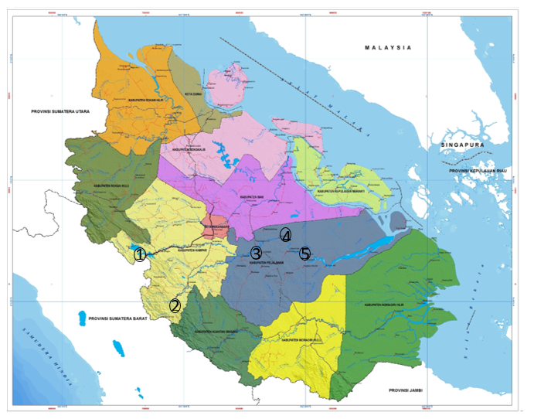
Figure 2. Sampling research at Kampar River

Secondary data as production of fish was obtained from the Marine and Fisheries Agency, Riau Province. The Growth parameter as K and t_{o} were obtained from desk study (Sani 2010). The data of length frequency and maturity stage for male and female were obtained from Wibowo (2010).

2.2. Data Analysis
Growth patterns
Growth pattern for feather back was analyzed using length-weight relationship with equations:

W=aL^{b}

Where:
W | = | Fish weight (kg)
L | = | Total length (cm)
a and b | = | Regression coefficient
Asympthotic length (L∞)
For L∞ estimation was calculated with Wetherall (1986) approach by the following steps:
- The determination of lowest limit from the fish length range (L ̅) was calculated by the equation:
$$\overline{L}$$ | = | $$\sum{FL/n}$$

Where:
F | = | Total length frequency of fish
$$\overline{L}$$ | = | Middle total length of fish
n | = | Number of fish with total length is larger than L’
L’ | = | Lower limit value of total length
- Regression between $\overline{L}$- L’ dengan L’
- Ratio Z/K

Z/K | = | -(1+b)/b
L∞ | = | -a/b

Where:
a | = | intercept
b | = | slope
k | = | Growth coefficient
Length at first catch and mature of fish
Length at first catch of father back was calculated using cumulative frequency curve (Beverton & Holt,1975) with equation:
$$L_{c}$$ | = | $$\overline{L}-k(L_{∞}-\overline{L})/Z$$
Where:
$$L_{c}$$ | = | Length at first capture (cm)
$$\overline{L}$$ | = | Average of total length of fish capture (cm)
$$k$$ | = | Growth coefficient (tahun⁻¹)
$$L_{∞}$$ | = | Asympthotic of total length (cm)
$$Z$$ | = | Total mortality rate (tahun⁻¹)

The length of first mature (L_{m}) was calculated using logistic curve (King, 2007) with formulation as:
P = 1/(1+exp[-r(L-Lm)
Where:
P | = | Proportion of fish mature (%)
L_{m} | = | The total length at stage mature of fish (cm)
L | = | Total length of fish (cm)
r | = | Slope
Spawning potential Ratio
Spawning potential ratio (SPR) can beused as conservation strategy for stock reproduction in fish population for precaution of overfishing recruitment (Slipke et al., 2002). Value of SPR usually was used for fisheries resources management (Goodyear, 1993; Ault et al., 2005; Prince et al., 2015). It was calculated based on Huo et al (2015) approach as
Potential Spawning Ratio (SPR) provides a conservation strategy to maintain the reproduction of a stock that is useful in preventing overfishing recruitment (Slipke et al., 2002). SPR methods are commonly used in the management of fish resources (Goodyear, 1993; Ault et al., 2005; Prince et al., 2015). The SPR value is calculated based on Huo et al (2015) equation as follows:
SPR | = | $$\frac{{SSBR}_{r}}{{SSBR}_{r=0}}x100$$

Where:
SPR | = | Spawning potential ratio of fish (%)
SSBR_{r} | = | Spawning stock biomass at exploitation (kg)
SSB₌₀ | = | Spawning stock biomass unexploitation (kg)

The limits of the SPR values used as the basis for the management of fish resources (Goodyear, 1989; Clark,1991):
- SPR < 20% | = | Decreasing of fish population
- 20% ≤ SPR > 30% | = | Sustainable of fish population
- SPR ≥ 35% | = | Increasing of fish population
Estimated for length at first capture with optimally economic value
Estimation length of first capture with optimally economic value was calculated based on King (1995) approach. The calculation was done with some steps as:
- Determination of fish length at age t (L_{t}) (Sparre & Venema, 1999)

L_{t}= L_{oo} (1-e^{-k(t-to)})
where:
L_{t} | = | Length at t age (cm)
L_{oo} | = | Asymptot length (cm)
k | = | Growth coefficient (per year)
t_{o} | = | Theorytically age at zero length (year)
t | = | Fish age at t (year)
- Growth pattern was determined by length weight-relationship
- Number of fish at t time (King, 1995)
N_{t+1} = N_{t} exp(-M)
Where:
N_{t+1} | = | Number of fish at time t+1 (individu)
N_{t} | = | Number of individu at time t (individu)
M | = | Natural mortality (per year)
- Total biomass of fish
B = (N_{t+1} x W)/1000
Where:
B = Total biomass of fish (kg)
- Economical value from fish harvest
VE = B x A
Where:
 | VE | = | Economic value from harvest (Rupiah)
 | A | = | Fish price (Rp/kg)

3. Result and Discussion
Total length and weight of feather back was catch in this research around 31,0-98,0 cm and 200-8.200 gr respectively. It’s was larger than feather back that was catch at Riam Kanan Reservoir with total length and weight around 14-74,5 cm and 100-3300 gr respectively (Umar & Kartamihardja, 2007). Length weight relationship were W =0,0006L^{3,6392} with R² = 0,9300 for female and W =0,0006L^{3,6335} with R² = 0,9275 for male (Figure 1).

The Feather back fish were capture during the study ranged from 31.0-98.0 cm with a weight ranging from 200 to 8,200 g. It was greater than the fish caught in Riam Kanan Reservoir, which range between 14-74.5 cm with a weight of 100-3300 g (Umar & Kartamihardja, 2007). The length-weight relationship of female and male respectively follow the equation W = 0.0006L3,6392 with value R² = 0,9300 and W = 0.0006L3,6335 with value R² = 0,9275 (Figure 3.)

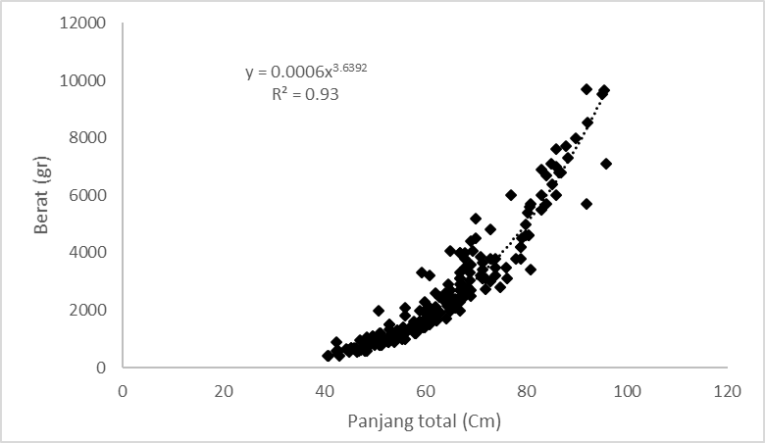  Female | 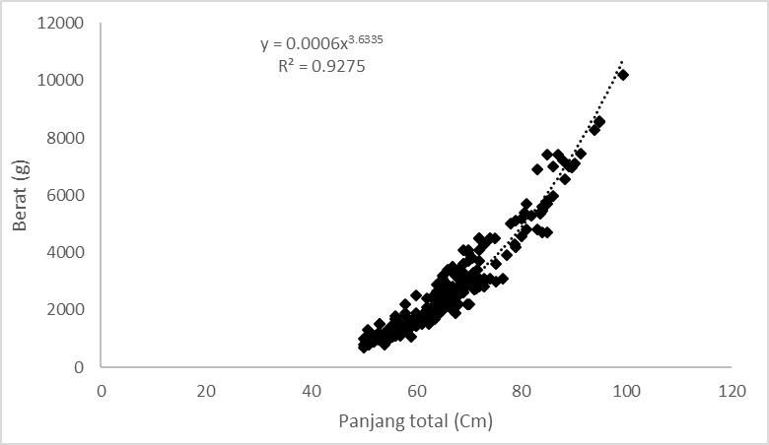  Male
Figure 3. Length-weight relationships of feather back fish at Kampar River

Growth patterns for male and female of feather back at Kampar River shown positive isometric (p≥0,05). Its indicated that the increasing of the weight of fish was faster than increasing of length. The result was same with Lestari (2010) report, which was isometric positive for feather back with b= 3,4612.
The average total length of fish was as an indicator of fish stock health (Klaer et al., 2012). The cumulative frequency of the total length was captured during the study that presented in Figure 4. The most dominant total length was caught in this research were 55-60 cm for female and 60-70 cm for male. The total length was greater when it compared with the results of the study from Lestari (2010) namely around 40-55 cm. The asymptotic length (L_{oo}) of feather back was estimated from the total length data frequency caught in the Kampar river 107.5 cm for 12,400 grams of weight. The asymptotic length of this study was greater when compared with Sani (2010) report was 96,1 cm.

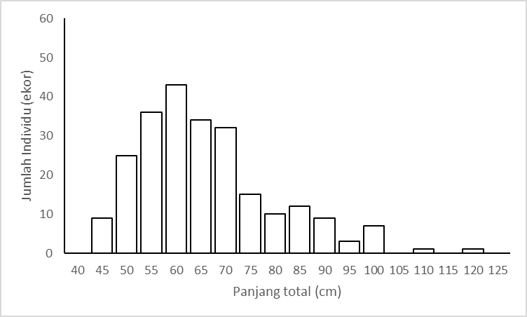  Female | 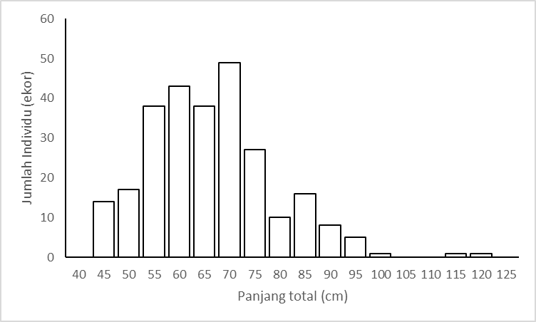  Male
Figure 4. Frequency distribution of feather back total length

Estimates of the total length at the first capture (L_{c}) for female and male fish were 45 and 53 cm, respectively. The size of the first mature (Lm) for female was 70 cm (Figure 5). The results of this study indicate that L_{m} in this research was smaller when it compared with Subagja et al. (2010) namely 68.4-82.5 cm with an average of 75.6 cm.

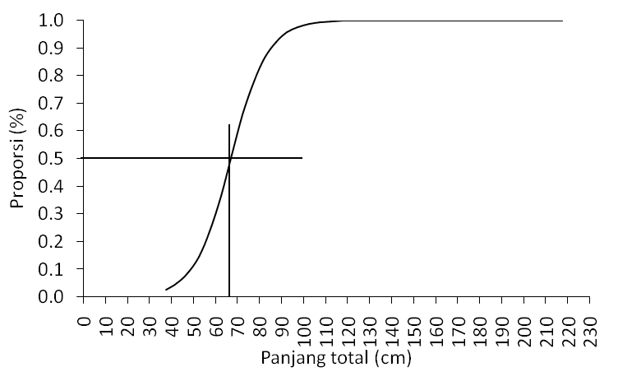
Figure 5. The mean total length at first mature (L_{m}) of feather back

The Lm value for Chitala lopis species is greater than Notopterus notopterus species with a total length of 13.5 cm for male and 16.2 cm for female fish (Gustomi et al., 2016). These feather back spawning during the rainy season around November-February (Wibowo & Sunarno, 2006). The total length size of the first fish caught (Lc) was smaller than the size of the first fish matured gonad (Lm). Its continuously could caused pressure of feather back population so that caused no recruitment
The SPR value at the first captured (L_{c}) was 5% while 30% of SPR value could been reached if the catch was in the length of fish after matured (L_{m}) (Figure. 6). The SPR method is a method used in the determination of the length of the Exploitative Portunus pelagicus Linnaeus, 1758 in Belitung (Ernawati et al., 2015) and red drum in the Atlantic Ocean (Vaughan, 2002).

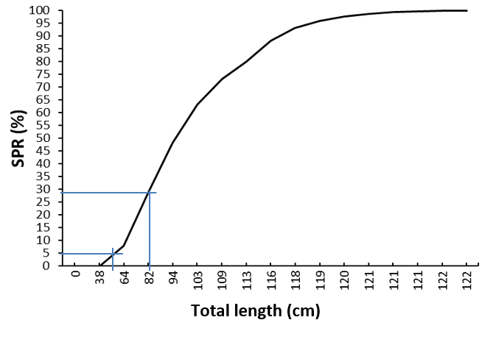
Figure 6. SPR Graphic and age of feather back at Kampar Riau

Based on L_{m} value showed that feather back was capture before spawning and caused recruitment overfishing. SPR value must be greater 30% for maintain of sustainability population. The effort for its in Kampar River as regulation of fish size for captured by limiting of mesh size of gear (Wibowo et al., 2010), so that capture of fish with longer than 80 cm.

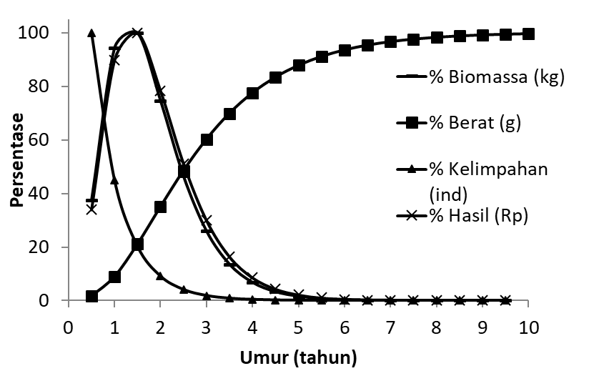
Figure 7. Relative biomass and economic value of feather back againts age

The highest economic value occurs when the harvest was done at total length of fish ≥ 80 cm or an average fish weight around 3.5 kg (Figure 7). Fish populations will decline gradually due natural mortality, which caused by predation or environmental degradation. The number of individual fish caught will be more if the exploitation is done less 80 cm of total length but the total biomass will become smaller. If exploitation is done at larger 80 cm the fish biomass will be optimal and economic valued too. This can happen because the caught fish has a larger individual size so that the total catch rate will be higher.

- CONCLUSION
The dominance of total length feather back was captured smaller than the length at first mature with SPR value was 5%. To ensure of fish populations sustainability, SPR value must be greater than 20%. This could be achieved if the total length of the exploited was 80 cm. In addition, exploitation at this total length also provides the optimal economic value for fisherman.

- REFERENCES
Aryani N. 2015. Native species in Kampar Kanan River, Riau Province Indonesia.International Journal of Fisheries and Aquatic Studies 2(5): 213-217
Ault J. S., S. G Smith & J. A Bohnsack. 2005. Evaluation of average length as an estimator of exploitationstatus for the Florida coral-reef fish community. ICES Journal of Marine Science 62: 417-423
Burnawi. 2011. Pengamatan isi lambung ikan belida (Chitala lopis) hasil tangkapan di Perairan Sungai Kampar, Riau. BTL 9(1): 41-44
Clark, W. G. 1991. Groundfish exploitation rates based on life history parameters. Canadia Journal of Fisheries and Aquatic Science 48(5): 734-750
Cope J. M & A, E Punt. 2009. Length-based reference points for data-limited situation: Apllications and restrictions. Marine and Coastal Fisheries: Dynamics, Management and Ecosystem Science1: 169-186
Carruthers, TR., Punt AE., Walters CJ., MacCall, A., McAllister MK., Dick EJ & Cope J. 2014. Evaluating methods for setting catch limits in data-limited fisheries. Fisheries Research 153: 48-68
Deroba J. J & J. R Bence. 2008. A review of harvest policies: Understanding relative performance of control rules. Fisherries Research 94: 210-223
Ernawati T., Duranta & Wagiyo K. 2015. Penentuan status sumberdaya rajungan (Portunus pelagicus Linnaeus, 1758) dengan metode

spawning potential ratio di perairan sekitar Belitung. J. Lit. Perikan. Ind 21(2): 63-70

Fithra R. Y & Y. I Siregar. 2010. Keanekaragaman ikan Sungai Kampar inventarisasi dari Sungai Kampar Kanan. Jurnal lingkungan 2(4):139-147
Goodyear, C. P. 1989. LSIM - A length-based fish population simulation model. NOAA Technical Memorandum NMFS-SEFC-219 iii plus 55 p.
Goodyear C. P. 1993. Spawning stock biomass per recruitment in fisheries management: foundation and current use.In Smit SJ. J Hunt & D Rivard (Edt). Rsik evaluation and biological reference points for fisheries Management. Can. Spec. Publ. Fish.Aquat. Sci 120: 67-81
Gustomi, A., Sulistiono & Yonvitner. 2016. Biologi reproduksi ikan belida (Notopterus notopterus Pallas, 1769) di kolong-Bendungan Simpur Bangka. Jurnal Ilmu Pertanian Indonesia 21(1): 56-62
Haryono. 2008. Potensi ikan belida dan upaya konservasinya. Fauna Indonesia 8(2): 5-8
Hordyk, A., Ono, K., Valencia, S., Loneragan, N & Prince, J. 2014. A novel length-based empirical estimation method of spawning potential ratio (SPR), and test of its performance, foor small-scale data poor fisheries. ICES Journal of Marine Science 9: 1-15
Huo B., B. S Ma. C. X Xie. Y. J Duan. X. F Yang & H. P Huang. 2015. Stock assessment and management implication of an endemic fish, Oxygymnocypris stewartii, in the Yarlung Zangbo River in Tibet, China. Zoological Studies 54: 1-15
King M. 1995. Fisheries Biology, Assessment and Management. Fishing News Books. Berlin: 34p
King, M. 2007. Fisheries biology, Assessment and Management. Blackwell Publishing. United States Of America. 382p.
Klaer N. L., S. E Wayte & G Fay. 2012. An evaluation of the performance of harvest strategy that uses an average –length-based assessment method. Fisheries Research 134-136: 42-51
Lestari M. 2010. Biologi reproduksi ikan belida (Chitala lopis) di daerah Aliran Sungai Kampar, Riau.Skripsi.Institut Pertanian Bogor. 60p
MacCall, A. D. 2009. Depletion-corrected average catch: a simple formula for estimating sustainable yields in data-poor situations. ICES Journal of Marine Science 66: 2267-2271
Prince J, D., N. A Downing. C. R Davies. R. A Campbell & D. S Kolody. 2011. A simple cost effective and scale less empirical approach to harvest strategies. ICES Journal of Marine Science 65(8): 947-960
Prince J. S Victor. V Kloulchad &A Hordyk. 2015. Length based SPR assessment of eleven Indo-Pasific coral reef fish population in Palau. Fish. Res (2015): http://dx.doi.org/10.1016/j.fishres.2015.06.008
Sani O. 2010. Studi habitat dan pertumbuhan ikan belida (Chitala lopis) di daerah perairan Sungai Kampar, Provinsi Riau.Skripsi. 82 p
Simanjuntak C. P. H. M. F Rahardjo & S. Sukimin. 2006. Iktiofauna rawa banjiran Sungai Kampar Kiri. Jurnal Iktiologi Indonesia 6(2): 99-1009
Slipke J. W., A. D Martin. J. P Junior & M. J Maceina. 2002. Use of the spawning potential ratio for the Upper Mississipi River Channel Catfish Fishery. North American Journal of Fisheries Management 22: 1295-1300
Subagja., Wibowo A & Marson.2010. Biologi reproduksi ikan belida (Chitala lopis) di dasrah aliran Sungai Kampar Riau. Seminar Nasional Tahunan VII: 1-9
Umar C & E. S Kartamihardja, 2007. Konservasi ikan belida (Chitala lopis) di Waduk Riam Kanan, Kalimantan Selatan.Dalam Rahardjo MF., et al. (edts). Forum Nasional Pemacuan Sumberdaya Ikan I: 263-272
Vaughan, D. S. 2002. Estimating improvement in spawning potential ratios for South Atlantic Red Drum through Bag and size limit Regulations. North American Journal of Fisheries Management 22: 895-906
Wayte S. E & N. L Klaer. 2010. An effective harvest strategy using improved catch-curves. Fisheries Research 106: 310-320
Wetherall J. A. 1986. A new method for estimateing growth and mortality parameters from length-frequency data. Fishbyte 4(1): 12-14
Wibowo A & M. T. D Sunarno. 2006. Karateristik habitat ikan belida (Notoptera Chitala): Bawal 1(1): 19-25
Wibowo, A & Marson. 2012. Fenomena plastisitas fenotipik ikan belida (Chitala lopis) di Sungai Kampar, Riau. Bawal 4(3): 195-204
Wibowo A. 2014. Food composition and niche characteristic of giant Feather Back (Chitala lopis) Bleek, Indoereivr 1851) In Kampar River, Indonesia.Fish. Res. J 20(1): 1-10
Wiedenmann J., M. J Wilberg & T. J Miller. 2013. An evaluation of harvest control rule for data-poor fiheries. North American Journal of Fisheries Management 33: 845-860.

