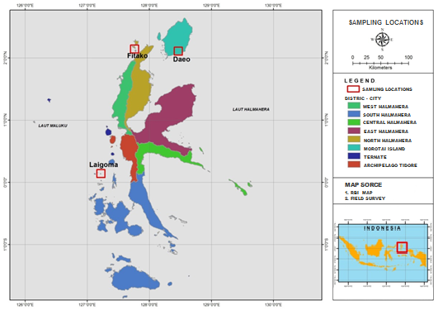
Figure 1. Sampling location of coconut crab in Daeo (Morotai Island), Laigoma (South Halmahera District) and Fitako (North Halmahera District).

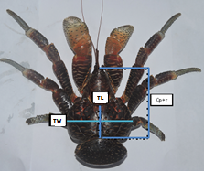
Figure 2. Measurement of cephalothorax length plus rostrum (Cp + r), thorax width (TW) and thorax length (TL) of coconut crab (Source: Fletcher, 1990).

A
B

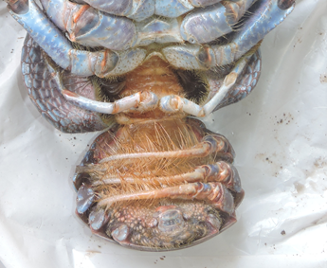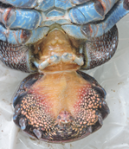
pleopod
Figure 3. Morphology differences of female (A) and male (B) coconut crab.

b
a
c

Figure 4. The relationship of cephalothorax plus rostrum (Cp+r) (a), thorax width (TW) (b), and thorax length (TL) (c) with weight.

