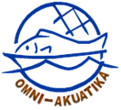
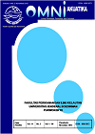
Omni-Akuatika, 11 (2): 1–5, 2017
ISSN: 1858-3873 print / 2476-9347 online
Research Article

The Adaptive Capacity of Corals Based on the Health Level to Estimate
the Carrying Capacity of the Marine Ecotourism in Enggano Island

Yar Johan ^{1,2*}, Fredinan Yulianda³, Rahmat Kurnia³, Ismudi Muchsin³

¹ Graduate School of Bogor Agricultural University, Jl. Raya Dramaga, Bogor 16680
² Study Program of Marine Sciences, Faculty of Agriculture, Bengkulu University, Jl. W.R Supratman, Bengkulu 38371
³ Faculty of Fisheries and Marine Sciences, Bogor Agricultural University, Jl. Raya Dramaga, Bogor 16680

*Corresponding author: yarjohan@gmail.com.
Abstract
Enggano Island is one of the outermost islands of Indonesia. Among the recoverable resources that exist in Enggano Island are coral reef ecosystems. A coral reef ecosystem is also one of the ecosystems with a high level of biodiversity productivity having a major role as habitats, feeding places, and the coastal protection from the crashing of waves and strong currents. Currently, coral reefs are being destroyed either by nature or humans. The ability of an ecosystem to adapt to a disturbance or potential damage is called adaptive capacity. The aim of the study was to assess the adaptive capacity of corals in terms of their health levels to estimate the carrying capacity of marine ecotourism. The observation method used was survey method. Adaptive capacity measurements were carried out by analyzing six parameters: hard coral cover (%), distances from human settlements (km), dominance of lifeform, types of lifeform, reef fish species, and coral reef depth (m). The results of this study showed that Enggano Island corals had the adaptive capacity that fell into two categories: medium and adaptive.

Keywords: adaptive capacity, coral reef, Enggano Island

1. Introduction
Enggano Island is one of the outermost inhabited islands that are located in North Bengkulu Regency, Bengkulu Province. Geographically, Enggano Island is located between 5017' South Lalitude-5031' South Lalitude and 102005' East Longitude-102025' East Longitude. The Enggano Island region includes several small islands, namely Dua Island, Merbau Island, and Satu Island. The distance from Bengkulu City is 156 km (90 nautical miles), and the closest distance to the mainland of Sumatra is Manna City, South Bengkulu Regency, about 96 km (60 miles). The sea transportation service of Enggano Island is using a ferry or pioneer ship with a travel time of about 14 hours and the air transportation service of Enggano Island is using a pioneer aircraft with a travel time of about 45-50 minutes. Both the transportation modes operate 2 times a week.

Enggano Island has a land area of ± 39 720 ha, with a long coastline of ± 112 km. The population of Enggano Island in 2016 was 3,091 people, spreading in six (6) villages, namely Banjar Sari Village, Meok Village, Apoho Village, Malakoni Village, Kaana Village and Kahyapu Village with a sub-district capital in Apoho Village. Meanwhile, there are several tribes on Enggano Island: Kauno, Kaitora, Kaarubi, Kaharuba, Kahaoa and Kamay (BPS Bengkulu Utara, 2016).

The main potential of the coastal ecosystems of Enggano Island are coral reef ecosystems. The ecosystems are typical of tropical regions with high levels of biodiversity productivity. In addition, the coral reefs also serve as habitats and feeding places, as well as the coastal protection from strong waves and currents. Currently, coral reef ecosystems are being destroyed either by nature or humans. According to Subur (2012), the adaptive capacity of coastal ecosystems such as coral reef ecosystem play an important role in the face of changes as well as external pressures. The ability of a system to adapt to a disturbance or potential damage is called adaptive capacity (Gallopin, 2006).
Adaptive capacity is also one dimension that causes vulnerability (Fussel and Kelin, 2006; Turner et al., 2003). It plays an essential role in reducing vulnerability, from high vulnerability to low vulnerability with high adaptive capacity or otherwise (Luers, 2005) The parameter which encompasses the adaptive capacity of corals is biophysical parameter. Considering the importance of the adaptive capacity of corals, it is necessary to carry out this research as the first step to assessing coral reef ecosystems in Enggano Island for specific purposes such as marine ecotourism. After the adaptive capacity of the coral ecosystems in Enggano Island was obtained, it would be decided whether it was categorized as not adaptive, moderately adaptive (medium) and adaptive. This also supports the efforts of Bengkulu Provincial Government which has established Enggano Island as the center of fishing and tourism industry for the Years 2013 to 2025.

2. Materials and Methods
Site and Time of Research
This research was conducted for 6 months in Enggano Island, North Bengkulu Regency, Bengkulu Province (Figure 1).

Materials and Research Tools
The materials and tools used in the research were a motor boat, Global Positioning System (GPS), Self- Contained Underwater Buoyancy Apparatus (SCUBA), slate / pencil, Underwater Camera, 50 m roller, digitized basemap, and other tools that supported data collection in the field.

Method of collecting data
The data collection was directly conducted in the field (in-situ) that covered six (6) research sites in Enggano Island, namely Satu Island, Lake Padipo, Merbau Island, Dua Island, Gosongseng Cape and Kaana (Figure 1). The data collected consisted of primary data and scondary data. The collection method was as follows:

Hard coral cover (%)
The data collection of hard coral cover used Line Intercept Transect (LIT) method by determining the coral lifeform and coral cover percentage (English et al., 1994). The data collection was done by spreading a 50-meter-transect line at each station point. Measurements of the lifeform of corals, coral species, and other benthic categories below the transect line were recorded with accuracy approaching centimeter, further identified in reference to Suharsono (2008) and Veron (2000).

Lifeform dominance
The data collection of lifeform dominance was similar to the data collection of hard coral cover. Any lifeform passed by the transect line was recorded and calculated to find out the most common type of lifeform compared to other lifeform types (English et al., 1994).

Number of lifeform types
The collection of the number of lifeform types was done by spreading the 50 m transect line at each station point. The measurement of this form of coral growth (lifeform) refers to English et al., (1994).

Number of reef fish species
The data collection on the number of reef fish species in this study used Underwater Visual Census (UVC) method with the purpose of identifying reef fish through the observation of reef fish encountered around the points of the research locations. The identification referred to Allen and Steene (1996) and Kuiter and Tonozuka (2001).
Distance between ecosystems and settlements
Collecting the data on the distance between the coral reef ecosystem and the settlement or community activity was done by using GPS.

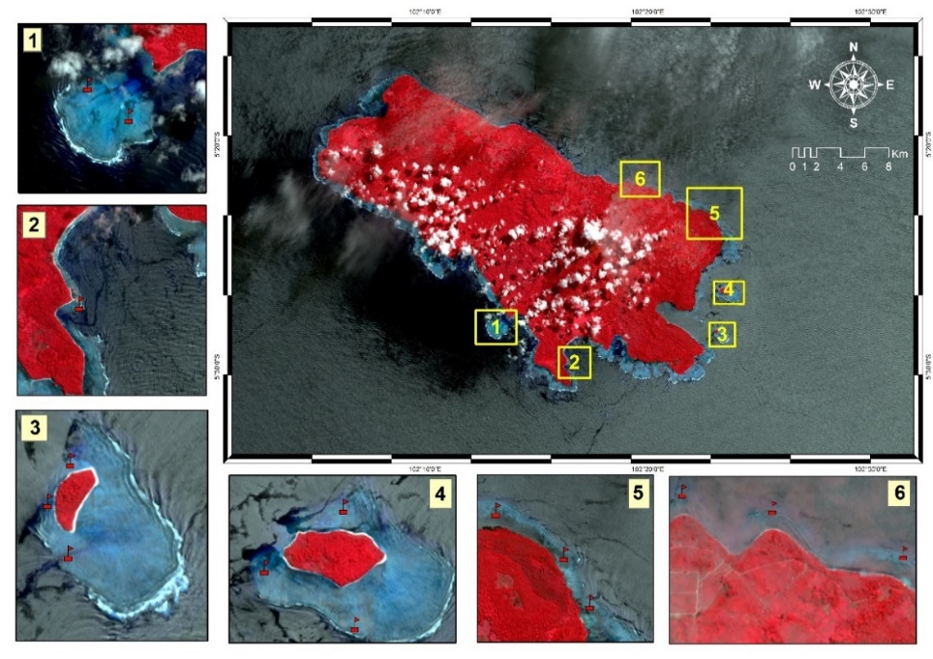

Figure 1. Site Map of Enggano Island Research

Data analysis of hard coral cover
The analysis of hard coral cover was conducted based on the following equation:

Note:
N = Percentage of coral cover
li = Total length of lifeform -i
L = Transect length is 50 m

The analysis of the conditions of coral reef ecosystem health based on hard coral cover refers to Gomez and Yap (1988). The coral health categories based on the hard coral cover can be seen in Table 1.

Table 1. Coral reef condition categories based on the percentage of hard coral cover
No | Hard Coral Cover (%) | Category
1 | >24.9 | Damaged
2 | 25-49.9 | Medium
3 | 50-74.9 | Good
4 | <75 | Very Good
Souce: Gomez and Yap (1988)

Analysis of Coral Capacity Adaptive
The assessment of the coral adaptive capacity analysis consisted of 6 parameters and 3 categories. There are 6 parameters of Anggano Island coral adaptive capacity (See Table 2): Number of coral hard cover (%), Dominance of lifeform, Number of lifeform species, Number of reef fish species, Coral reef depth, and Distance of the coral reef ecosystems from the community settlements .

Table 2. Matrix of the Assessment of the coral adaptive capacity

No | Parameter | Weight | Score |  |  | Notes
No | Parameter | Weight | 1 | 3 | 5 | Notes
No | Parameter | Weight | Not Adaptive | Medium | Adaptive | Notes
1 | Hard coral cover (%) | 5 | <25 | 25-50 | >50 | Modified from Gomez and Yap (1988)
2 | Dominance of lifeform | 5 | SC, OT, CB | ACT, ACD,CE | CM, CS | Yulianda (p.c 13 January 2017)
3 | Type of lifeform | 3 | <7 | 7-15 | >15 | Modified from Yulianda 2007
4 | Coral fish species | 3 | <30 | 30-80 | >80 | Modified from Yulianda 2007
5 | Depth of coral reef (m) | 1 | 1-3 | 3-10 | >10 | Modified from Yulianda 2007
6 | Distance from community settlement (km) | 1 | <1 | 1-5 | >5 | Yulianda (p.c 13 January 2017)
Notes: p.c = personnel communication. CM = coral massive; CS = Coral submassive; CE = Coral encrusting; SC = Soft Coral; Ot = Other; ACT = Acropora tubular; ACD = Acropora digitate. * Index dimensions (0-5). Max Value: 90

Analysis of the coral adaptive capacity (KAK) is the continuation of the adaptive capacity assessment matrix. The formula used to calculate the coral adaptive capacity refers to Fertile et al. (2011).

Note:
KAK: Value of Coral Adaptive Capacity
Ni: Total parameter value of the measurement result
Nmax: Maximum value of the parameter
The value of the coral adaptive capacity was in the range of 0.0-1.0, with three categories consisting of "not adaptive (0.0≤KAK≤0.33)". "Medium (0.33 <KAK≤0.67)" and "adaptive (0.67 < ≤1.0) ".

3. Results and Discussion
Hard coral cover values in six study sites were between 16.08-64.4%. The highest hard coral cover was found at Gosongseng Cape at 64.4%, followed by Satu Island (46.03%), Merbau Island (39.41%), Kaana (35.9%), Lake Padipo (27.95%) and Dua Island (16.08%) as can be seen in Figure 2. Some hard corals found in Enggano Island can bee seen in Figure 3.

Figure 2. The percentage value of hard coral cover at the study sites

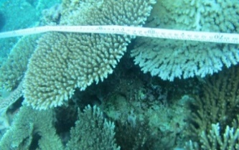
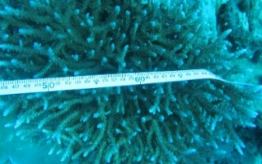
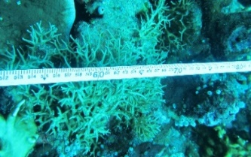
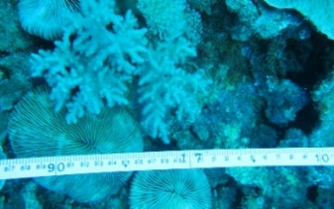
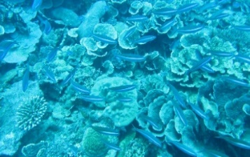
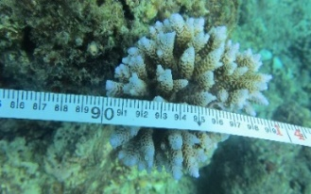

Figure 3. Some hard corals in Enggano Island

The research results showed that the coral health value of Gosongseng Cape based on Gomez and Yap (1988) formulation was in the criteria of good (50.00-74.90%). Based on the coral health criteria, Dua Island was categorized as damaged. Meanwhile, Kaana, Lake Padipo, Satu Island and Merbau Island were categorized as medium. Subur (2012) states that the high value of hard coral cover indicates a good health level, and this in turn will ensure the survival and existence of coral reef ecosystems. The coral cover value which is likely to be low will create favorable conditions for macroalgae growth which in turn kills corals. When disturbances occur, many corals die. The corals will soon be covered by algae because macroalgae grow very fast. Hughes et al., (2006) said that macroalgae inhibited coral colony passing (Lirman, 2001).
In general, lifeform is dominated by branched coral lifeform (ACB) which could be seen in Satu Island, Gosongseng Cape and Lake Padipo (See Figure 4). The shape of branched coral growth is relatively fragile and can not stand the waves nor the waves that pass through it, especially in the shallow waters. This is in contrast with massive corals, which are more resistant to disturbances (Brown and Suharsono, 1990; Marshall and Baird, 2000; Ninio and Meekan, 2002).

Note: ACB = Acropora Branching, ACD = Acropora Digitate, ACS = Acropora Submassive

Figure 4. Comparison of lifeform dominance, lifeform types and reef fish species.

Based on Figure 4, there are about 4-11 lifeform species, consisting of Acropora Brancing (ACB), Acropora Digitate (ACD), Acropora Tabulate (ACT), Acropora Submassive (ACS), Acropora Encrusting (ACE), Coral Branching (CB) , Coral Encrusting (CE), Coral Massive (CM), Coral Submassive (CS), Coral Foliose (CF), and Coral Mushroom (CMR). According to Lidlie et al., (2007); Wilsom et al., (2007), the structural inheritance of coral reefs is coral reef lifeform which can survive from any disturbance, and this is the complexity of coral habitats and subtrates. Complex habitats can preserve the diversity of fish and improve coral recruitment, which is essential in the recovery of coral ecosystems.
The coral reef depth is one of the parameters to measure the adaptive capacity of corals The depth of coral reef ecosystems in Enggano Island ranges from 3 to 10 m; that is why, the area will be utilized as marine ecotourism. In a certain area, the depth of the waters could reach 25 m, and the penetration level of the sunlight depends on the intensity of the light. Siringoringo et al., (2014) stated that the condition of basic substrates greatly influence the success of coral polyps to grow and develop into adult corals. Babcock and Smith (2000); Torres and Morelock (2002) stated that sedimentation and suspended materials in the water column affect coral growth by covering the polyp surface causing death. This can reduce the water brightness and ultimately disturb the coral physiological process, especially photosynthesis. As a result, there is a decrease in the percentage of coral cover. According to Thamrin (2006), species diversity and best growth were found at depths between 3-10 m.
The distances of coral reef ecosystems from the residential areas should be carefully considered. According to Algar et al., (2002), the closer the resources to human activities, the more vulnerable the resources, while the more isolated or further away from human activities, certainly the more preserved they would be. Based on the study results, in Gosongseng Cape, Satu Island, and Lake Padipo, the distances between coral reefs and settlements are > 5 km, but in Dua Island the distance is close to the residential area. Furthermore, the coral reef destruction was thought to be caused by the increased intensity of human activity (Wahidin et al., 2014), such as searching for shells during the lowest tide, standing and stepping on corals when snorkeling or swimming (Luthfi, 2016).

Analysis of the Adaptive Capacity of Enggano Island Coral
Based on the analysis results of the six parameters, the adaptive capacity of coral reefs was distributed in two categories that were medium and adaptive. The value of the adaptive capacity of Gosongseng Cape (0.78) was in the adaptive category, while the value of the adaptive capacity of Satu Island (0.60), Lake Padipo (0.67), Merbau Island (0.60) and Kaana (0.60), and Dua Island (0.36) was in the medium category. See Table 3 .

Table 3. Distribution of the Catagories of the Coral Adaptive Capacity at each study site

No | Research Site | Parameter |  |  |  |  |  | KAK | KTG
No | Research Site | TKK | DL | JL | JIK | KTK | JPP | KAK | KTG
1 | Satu Island | 46.03 | ACB | 6 | 30 | 3-7 | >5 | 0.60 | Medium
2 | Lake Padipo | 27.95 | ACB | 4 | 30 | 3-7 | >5 | 0.67 | Medium
3 | Merbau Island | 39.41 | ACD | 7 | 59 | 6-10 | 1-5 | 0.60 | Medium
4 | Dua Island | 16.08 | ACD | 10 | 29 | 3-7 | >1 | 0.36 | Medium
5 | Gosongseng Cape | 64.4 | ACB | 11 | 40 | 3-10 | >5 | 0.78 | Adaptive
6 | Kaana | 35.9 | ACS | 6 | 30 | 3-10 | >5 | 0.60 | Medium
Note: TTK = Coral Cover (%). DL = Domination of Lifeform. JL = Number of Lifeform Types. JIK = Total Species of Coral Fish. CEC = Depth of Coral Reefs. JPP = Distance from Settlement. KAK = Adaptive Capacity of Coral. KTG = Category.

The value of the adaptive capacity of Dua Island corals was 0.36, the lowest value that belonged to the medium category due to the low hard coral cover in the waters. This was allegedly due to the activity of the port near Dua Island and the many fishing vessels from outside Enggano Island which dropped their anchors which damaged the coral reef ecosystem. Based on the monitoring results, there were at least 5 fishing vessels that dropped their anchors in every full moon, when fishermen stopped their fishing activities. The many broken corals or rubbles found were the evidence that the damage to coral reefs was due to the anchors of ships. This is supported by Burke et al., (2002), saying that other factors causing coral reef death include the dropping of ship’s anchor which is not environmentally friendly.
According to Subur (2012), the levels of adaptive capacity values were determined by the parameters studied. Meanwhile, according to Alger et al., (2002), the closer the resources to human settlements or human activities, the more vulnerable the resources. Therefore, it is necessary for Dua Island to be well managed so that the destruction of the coral reefs can be minimized.

4. Conclusion
The adaptive capacity value of Enggano Island was classified into two (2) categories--medium and adaptive. The coral whose adaptive capacity value was categorized as adaptive was found in Gosongseng Cape, and as medium in Satu Island, Lake Padipo, Merbau Island, Kaana and Dua Island.

5. Acknowledgements

We wish to thank Coremap-CTI 2015 for funding this research. We would also like to express our appreciation to Sub-district Head of Enggano, all Tribe Heads of Enggano Island, and Bengkulu University for their encouragement and support. Finally, we are greatly indebted to Ali Muqsit, S.Kel, M. Si, Muhammad Andre Nugraha, S.Kel, Agus Riansyah, S.Kel, Ayub Sugara, S.Kel for their assistance as the research team in the data collection in the field.

References
Allen, G.R., Steene, R. 1996. Indo-Pacific Coral Reef Field Guide. Singapore (ID); Tropical Reef Research.
Algar, D.A., Burbidge, A.A, Angus, G.J. 2002. Cat eradication on Hermite Island, Montebello Islands, Western Australia. In: Turning the tide: the eradication of island invasive species. CR Veitch and MN Clout (eds.), IUCN SSC Invasive Species Specialist Group, IUCN, Gland, pp. 14–18
Babcock, R., Smith, L. 2000. Effects of Sedimentation on Coral Settlement and Survivorship. In: Barbara A.B., R.S. Pomeroy, and C.M. Balboa (Eds.). Proceeding 9th International Coral Reef Symposium. Indonesia (ID):
BPS Bengkulu Utara. 2016. Statistik Daerah Kecamatan Enggano 2016. Argamakmur (ID): BPS Bengkulu Utara.
Brown, B., Suharsono. 1990. Damage and recovery of coral reefs affected by El Nino related seawater warming in the Thousand Islands, Indonesia. J Coral Reefs. 8:163-170.
Burke, L., Raytar, K., Spalding, M., Pery A. 2002. Reef at risk in Southeast Asian Washington DC; World Resources Institute.
English, S., Wilkinson, C,. Baker, V. 1994. Survey manual for tropical marine resources. Australian Institute of Marine Science. Townsville (ID):
Fussel, H.M., Klein, R.J.T. 2006. Climate Change Vulnerability Assessments: An Evolution of Conceptual Thinking. J Climate change. 75: 301-329
Gallopin, G.C. 2006. Linkages between vulnerability, resiliensi, and adaptive capacity. J Global Environ. Change. 16:293-303.
Gomez, E.D., Yap, H.T. 1988. Monitoring Reef Condition. P:187-195 dalam R.A. Kenchington dan B.E.T. Hudson (eds.), Coral Reef Management Handbook. UNESCO Regional Office for Science and Technology for South East Asia. Jakarta (ID):
Hughes, T.P., Bellwood, D.R., Folke, C.S., McCook, L.J., Pandolfi, J.M. 2006. NoBTake Areas, herbivory and coral reef resilience. TRENDS in Ecology and Evolution. 22: 1-3.
Kuiter, R.H., Tonozuka, T. 2001. Indonesian Reef Fishes (Part 1 dan 2). Zoonetic. Australia (ID); Zoonetics.
Ledlie, M.H., Graham, N.A.J., Bythell, J.C., Wilson, S.K., Jennings, S., Polunin, N.V.C., Hardcastle, J. 2007. Phase shifts and the role of herbivory in the resilience of coral reefs. J.Coral Reefs. 26:641–653
Lirman, D. 2001. Competition between macroalgae and corals: Effects of herbivore exclusion and increased algae biomass on coral survivorship and grouwth. J Coral Reefs. 19:392-399.
Luers, A.L. 2005. The surface of vulnerability: an analytical framework for examining environmetal change. J Glo Inveron Cha. 15: 214-223
Luthfi, O.M. 2016. Konservasi terumbu karang di pulau sempu menggunakan konsep taman karang. JIAT. 2 (1): 210-2016.
Marshall, P.A., Baird, A.H. 2000. Bleaching of corals on the Great Barrier Reef:differential susceptibilities among taxa. J. Coral Reefs.19:155–163.
Ninio, R., Meekan, M.G. 2002. Spatial patterns in benthic communities and the dynamics of a mosaic ecosystem on the Great Barrier Reef, Australia. J. Coral Reefs: 21:95–103.
Siringoringo, R.M., Palupi, R.D., Hadi, T.A. 2012. Biodiversitas Karang Batu (Scleractinia) di Perairan Kendari. IJMS. 17 (1): 23-30.
Subur, R., Yulianda, F., Fahrudin, A., Susilo, S.B. 2011. Kapasitas Adaptif Ekosistem Lamun (Seagrass) di Gugus Pulau Guraici Kabupaten Halmahera Selatan. J. Agrisains. 12 (3):207-215.
Subur, R. 2012. Daya Dukung Ekowisata Dengan Pendekatan Kapasitas Adaptif Ekologi di Pulau-Pulau Keci. Kasus Gugus Pulau Guraici Kabupaten Halmahera Selatan [Disertasi]. Bogor (ID): Institut Pertanian Bogor.
Suharsono. 2008. Jenis - jenis Karang di Indonesia. Jakarta (ID):Coremap Program LIPI Press.
Thamrin. 2006. Karang. Biologi Reproduksi dan Ekologi. Pekanbaru (ID): Minamandiri Press.
Torres, J.L., Morelock, J. 2002. Effect of Terrigenous Sediment Influx on Coral Cover and Linear Extention Rates on Three Caribbean Massive Coral Species. Caribbean Journal of Science. 38 (3-4): 000-000.
Turner, B.L. I.I, Kasperson, R.E., Matson, P.A., McCarthy, J.J., Corell, R.W., Christensen, L., Eckley, N., Kaspersnon, J.X., Luers, A., Martello, M.L., Polsky, C., Pulsipher, A., Schiller, A. 2003. A Framework For Vulnerability Analysis in Sustainability Science. Journal PNAS (Proc. Natl. Acad. Sci.) USA. 100: 8074-8079.
Veron, J.E.N. 2000. Corals of the world Vol.1. Australian Institute of Marine Science, PMB3. Townsville MC. Qld4810. Australia. 463 p.

Wahiddin, N., Siregar, V.P., Nababan, B., Jaya, I., Wouth, S. 2014. Deteksi Perubahan Habitat Terumbu Karang Menggunakan Citra Landsat Di Pulau Morotai Provinsi Maluku Utara. Jurnal Ilmu dan Teknologi Kelautan Tropis. 6 (2): 507-524.

Wilson, S.K., Graham, N.A.J., Polunin, N.V.C. 2007. Appraisal of visual assessments of habitat complexity and benthic composition on coral reefs. J. Mar Biol. 151:1069–1076.
Yulianda, F. 2007. Ekowisata Bahari sebagai Alternatif Pemanfaatan Sumberdaya Pesisir Berbasis Konservasi. Makalah Seminar Sains 21 Februari 2007. Departemen Manajemen Sumberdaya Perairan. FPIK IPB. Bogor.

